# DAE 8th Example 3.7

## Given:

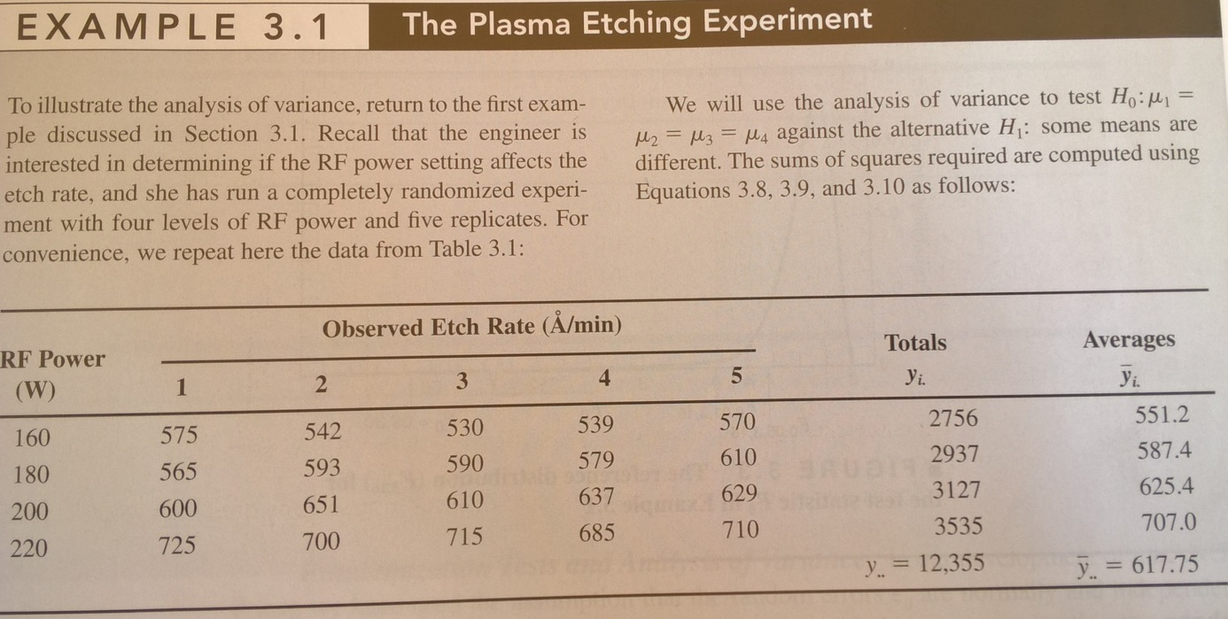

Use **Tukeys test** to investigate pairwise differences between treatments in the data from example 3.1

## Solution:

In MATLAB code

%DAE 8th Example 3.7

%Tukeys test, pairwise differences in the mean

%H0: µi=µj

%H1: not

alfa=0.05;

% The data.

Y=[575, 542, 530, 539, 570;

565, 593, 590, 579, 610;

600, 651, 610, 637, 629;

725, 700, 715, 685, 710];

a=size(Y,1); %number of treatments

n=size(Y,2); %number of replicates for each treatment

N=a*n;

n_vector=n*ones(size(Y,1),1);

y_mean=mean(Y,2); %means wrt the treatments

y_mean_max=max(y_mean);

y_mean_min=min(y_mean);

S_i=std(Y,0,2);

MSE=((n_vector-1)'*S_i.^2)/(N-a); %note the vector operation

%this was called Sp^2 in exampe 3.4. What's the difference?

q=qdist(alfa,a,N-a); %I found this function at https://se.mathworks.com/matlabcentral/fileexchange/49144-qdist-alpha-k-v-

%The statistic

T005=q*sqrt(MSE/n); %33.0536

%Therefore any difference in means which are greater in absolute value

%indicate a significant difference

D=pdist2(y_mean,y_mean); %the absolute values of the differences between the means

% D =

%

% 0 36.2000 74.2000 155.8000

% 36.2000 0 38.0000 119.6000

% 74.2000 38.0000 0 81.6000

% 155.8000 119.6000 81.6000 0

D>T005

%

% ans =

%

% 0 1 1 1

% 1 0 1 1

% 1 1 0 1

% 1 1 1 0

Therefore all the different levels of the etching process produce different effect on the response